Source Data Mapping Approach to CDMV5.4

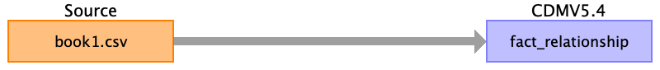

Table name: person

Table name: observation_period

Table name: visit_occurrence

Table name: visit_detail

Table name: condition_occurrence

Table name: drug_exposure

Table name: procedure_occurrence

Table name: device_exposure

Table name: measurement

Table name: observation

Table name: death

Table name: note

Table name: note_nlp

Table name: specimen

Table name: fact_relationship

Reading from book1.csv

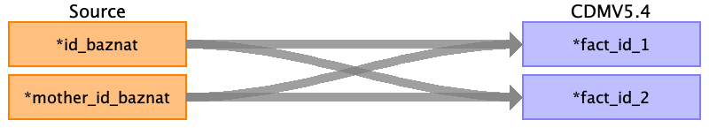

|  |  |  |  |
| --- | --- | --- | --- |
| Destination Field | Source Field | Logic | Comment |
| domain_concept_id_1 |  |  | person concept id = 56 |
| fact_id_1 | mother_id_baznat  ﻿id_baznat |  | infant  mother |
| domain_concept_id_2 |  |  | person concept id = 56 |
| fact_id_2 | ﻿id_baznat  mother_id_baznat |  | mother  infant |
| relationship_concept_id |  |  | infant of subject concept id = 42539764  mother of subject concept id = 40478925 |

Table name: location

Table name: care_site

Table name: provider

Table name: payer_plan_period

Table name: cost

Table name: drug_era

Table name: dose_era

Table name: condition_era

Table name: episode

Table name: episode_event

Table name: metadata

Table name: cdm_source

Table name: cohort

Table name: cohort_definition

Appendix: source tables

Table: book1.csv

|  |  |  |  |
| --- | --- | --- | --- |
| Field | Type | Most freq. value | Comment |
| ﻿id_baznat | INT |  |  |
| mother_id_baznat | INT |  |  |
| hosp_entry_date | INT |  |  |
| hosp_exit_date | INT |  |  |
| event_baznat | INT |  |  |
| emg_event_baznat | INT |  |  |
| cham_hosp_entry_date | INT |  |  |
| cham_hosp_exit_date | INT |  |  |
| age_category | INT |  |  |